Game Design Document

Fill up the Following document

1. Write the title of your project.

Fruit Slice

1. What is the goal of the game?

Slice all the fruits and try not to slice bombs. Don’t let the goblins get your fruits.

1. Write a brief story of your game?

Alicia went to a fair. After playing all the games, she had no more money but she sees a game she really wants to play. It is a game where you slice fruits and you don’t slice bombs. If you slice the bombs you lose! Help Alicia make this game on her computer.

1. Which are the playing characters of this game?

* Playing characters are the ones which respond to the user based on the input from the user
* Cars, monkeys, dinos, wizards etc, are the playing characters in the game.

|  |  |  |
| --- | --- | --- |
| Number | Character Name | What can this character do? |
| 1 | A girl | This girl can walk up to fruits and cut them down. She can also kill goblins that try to steal her fruit. |
| 2 |  |  |
| 3 |  |  |
| 4 |  |  |
| 5 |  |  |
| 6 |  |  |
| 7 |  |  |
| 8 |  |  |

1. Which are the Non Playing Characters of this game?

* Non Playing characters are the ones which don't have an action or a behaviour when the user interacts with the game.
* Hurdles, stones, bananas, coins, etc are non playing characters in the game.

|  |  |  |
| --- | --- | --- |
| Number | Character Name | What can this character do? |
| 1 | Goblins | This character shows up at random times and tries to steal fruits. |
| 2 |  |  |
| 3 |  |  |
| 4 |  |  |
| 5 |  |  |
| 6 |  |  |
| 7 |  |  |
| 8 |  |  |

Draw your imagination of this game. What does this game look like?

* Draw the game either on your computer or on paper,
* Add images of scenes of the game to show each of the playing and non-playing characters at least once.

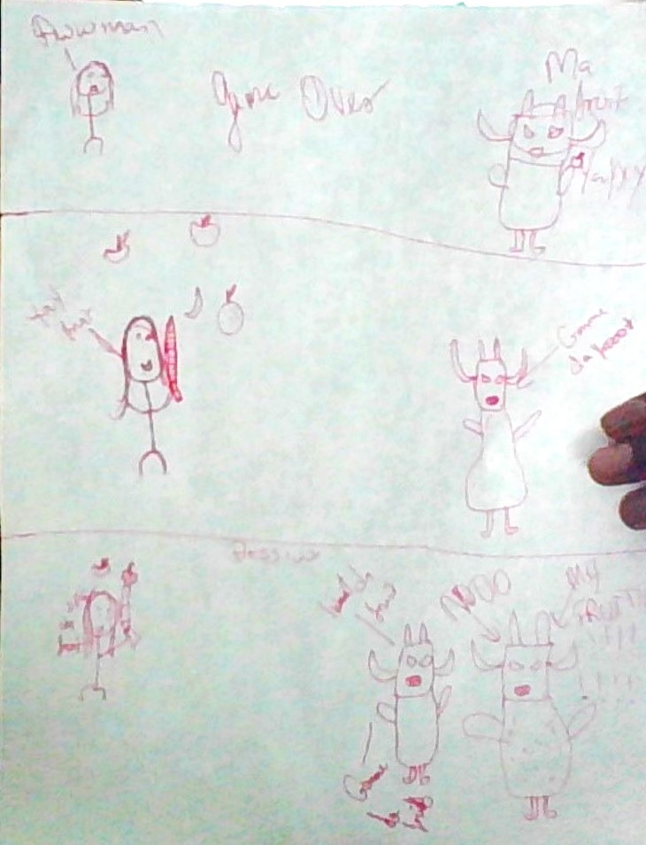

How do you plan to make your game engaging?

Increase speed of falling fruit every time Alicia slices 15 fruits. More goblins appear every time. Game ends if Goblin(s) get more than 20 fruits.